**TASK 14: Reproduction Test (81 marks)**

Students will complete a number of questions relating to reproduction. These questions will address specific content as well as analysis of second hand data. This task will be completed in one session under test conditions.

**Time for the tasks (1 hour)**

* 5 minutes reading time
* 55 minutes working time

**What you need to do:**

* Follow the instructions provided very carefully to complete the test.
* Draw any results in pencil and answer all questions given.
* It is your responsibility to organise your time effectively.
* There is to be no discussion between you or any of your class mates.
* No sharing of any equipment or answers at all.

|  |  |  |  |
| --- | --- | --- | --- |
| SECTION | Question Type | Marks available | Your mark |
| A | Multiple Choice | 14 |  |
| B | Short Answer | 39 |  |
| C | Extended response. | 28 |  |
|  |  | 81 |  |

**DO NOT TURN THIS PAGE OVER UNTIL YOU ARE TOLD TO**

**STUDENT NAME: __________________________________________________________________**

**TEACHER:**  Mrs Cunningham YEAR: 11

PART A: Multiple choice questions.

Please mark your answers in the answer section provided and NOT on the questions.

1. The sex of a foetus can generally be determined after

1. 8 weeks
2. 16 weeks
3. 24 weeks
4. 30 weeks

2. The milk secreting regions of the human breast are called

1. lobules
2. lobes
3. alveoli
4. areola

3. The best advantage of breast feeding over bottle feeding is

1. the milk does not need to be warmed
2. breast milk contains antibodies which protect the child against disease
3. breast milk does not contain too much fat
4. breast milk does not cause colic

4. After what stage of pregnancy is the ‘baby’ called a foetus?

(a) conception

(b) 16 weeks

(c) 8 weeks

(d) 12 weeks

5. The mother’s first secretion from her breast just after the baby is born is called

1. puerperium
2. vernix
3. colostrum
4. mastitis

6. When a child is born what part of its body takes up the greatest proportion of it?

1. legs
2. arms
3. trunk
4. head

7. According to the graph below, what percentage of the total brain weight is a baby born with?

(a) 27%

(b) 15%

(c) 47%

(d) 52%

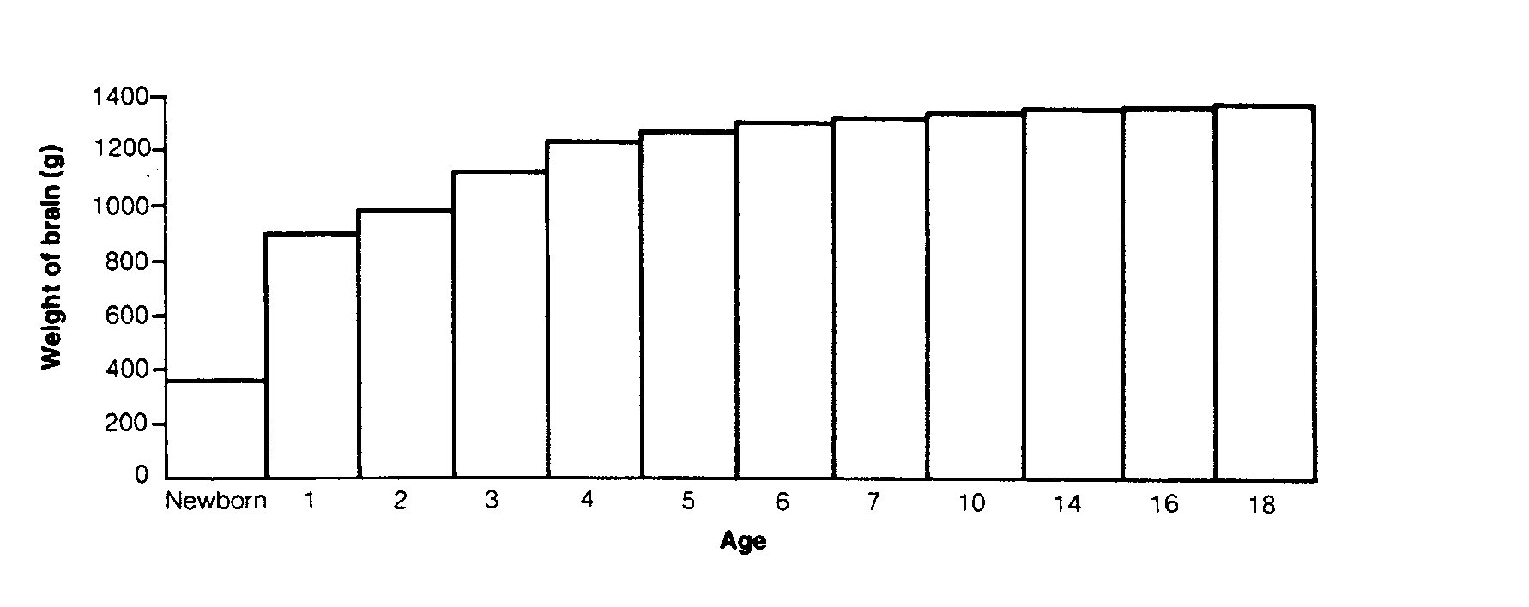

8. A zygote is the cell that results from the union of two

1. gametes
2. eggs
3. chromosomes
4. genes

9. The development into sexual maturity is termed

1. adolescence
2. growing pains
3. puberty
4. maturity

10. During the time that a foetus is developing inside the uterus

1. it uses food that has been stored in the placenta
2. it is nourished via the umbilical cord .
3. it uses food stored in a yolk
4. it is supplied with nutrients from the amniotic fluid

11. During which stage of labour is the baby actually born?

1. first
2. second
3. third
4. initial

12. The primary germ layer known as ectoderm gives rise to which of the following structures in the embryo

1. nervous system and skin
2. muscle and blood
3. lining of the respiratory system
4. lining of the kidneys

13. What is the function of the umbilical artery?

(a) Connect maternal blood to foetal blood.

(b) Carry deoxygenated, nutrient depleted blood from foetus to the placenta

(c) Carry oxygenated, nutrient rich blood from the placenta to the foetus

(d) Carry oxygenated, nutrient rich blood from the foetal heart to other body areas.

14. Which of the following cannot cross the placenta?

(a) Glucose

(b) Oxygen

(c) Red blood cells

(d) Rubella virus

END OF MULTIPLE CHOICE QUESTION SECTION

PART B: Short Answer questions. [39 marks]

Please write your answers in the spaces provided on this sheet.

1. Terminology – write the correct term for each definition below

|  |  |  |
| --- | --- | --- |
| **No.** | DEFINITION | TERM |
| **1** | Innermost lining of the uterus |  |
| **2** | Organ in the uterus which sustains the foetus |  |
| **3** | Normal duration of human gestation |  |
| **4** | Membrane that encloses the foetus in a fluid filled sack |  |
| **5** | Hormone which causes uterine contractions |  |
| **6** | The primary germ layer which forms the muscles, connective tissue and alimentary canal |  |
| **7** | Part of the blastocyst which develops into the embryo |  |
| **8** | Uses inaudible, high frequency sound waves to produce an image of the foetus. |  |
| **9** | A man’s sperm being used to fertilise a woman’s egg in a glass dish. |  |
| **10** | The placenta is attached to the foetus by this structure |  |

[10 marks]

2. List three symptoms of early pregnancy.

1. __________________________________________________________________
2. __________________________________________________________________
3. __________________________________________________________________

[3 marks]

3. Explain the extent to which the following are affected in a pregnant woman.

(a) Uterus _______________________________________________________________________

______________________________________________________________________

(b) Heart ______________________________________________________________________

______________________________________________________________________

[c] Bladder

_______________________________________________________________________

_______________________________________________________________________

1. Breasts

______________________________________________________________________________________________________________________________________________

[4 marks]

4. State what happens in the three stages of labour;

Stage 1 ________________________________________________________________

Stage 2 ________________________________________________________________

Stage 3 ________________________________________________________________

[3 marks]

5. (a) List three substances which pass across the placenta **FROM** the mother to the baby.

1. _________________________ 2. _______________________

3. ________________________

[3 marks]

(b) List two substances which pass across the placenta **FROM** the baby to the mother.

1. _________________________ 2. _______________________

[2 marks]

6. Label the following diagram in the spaces provided below.

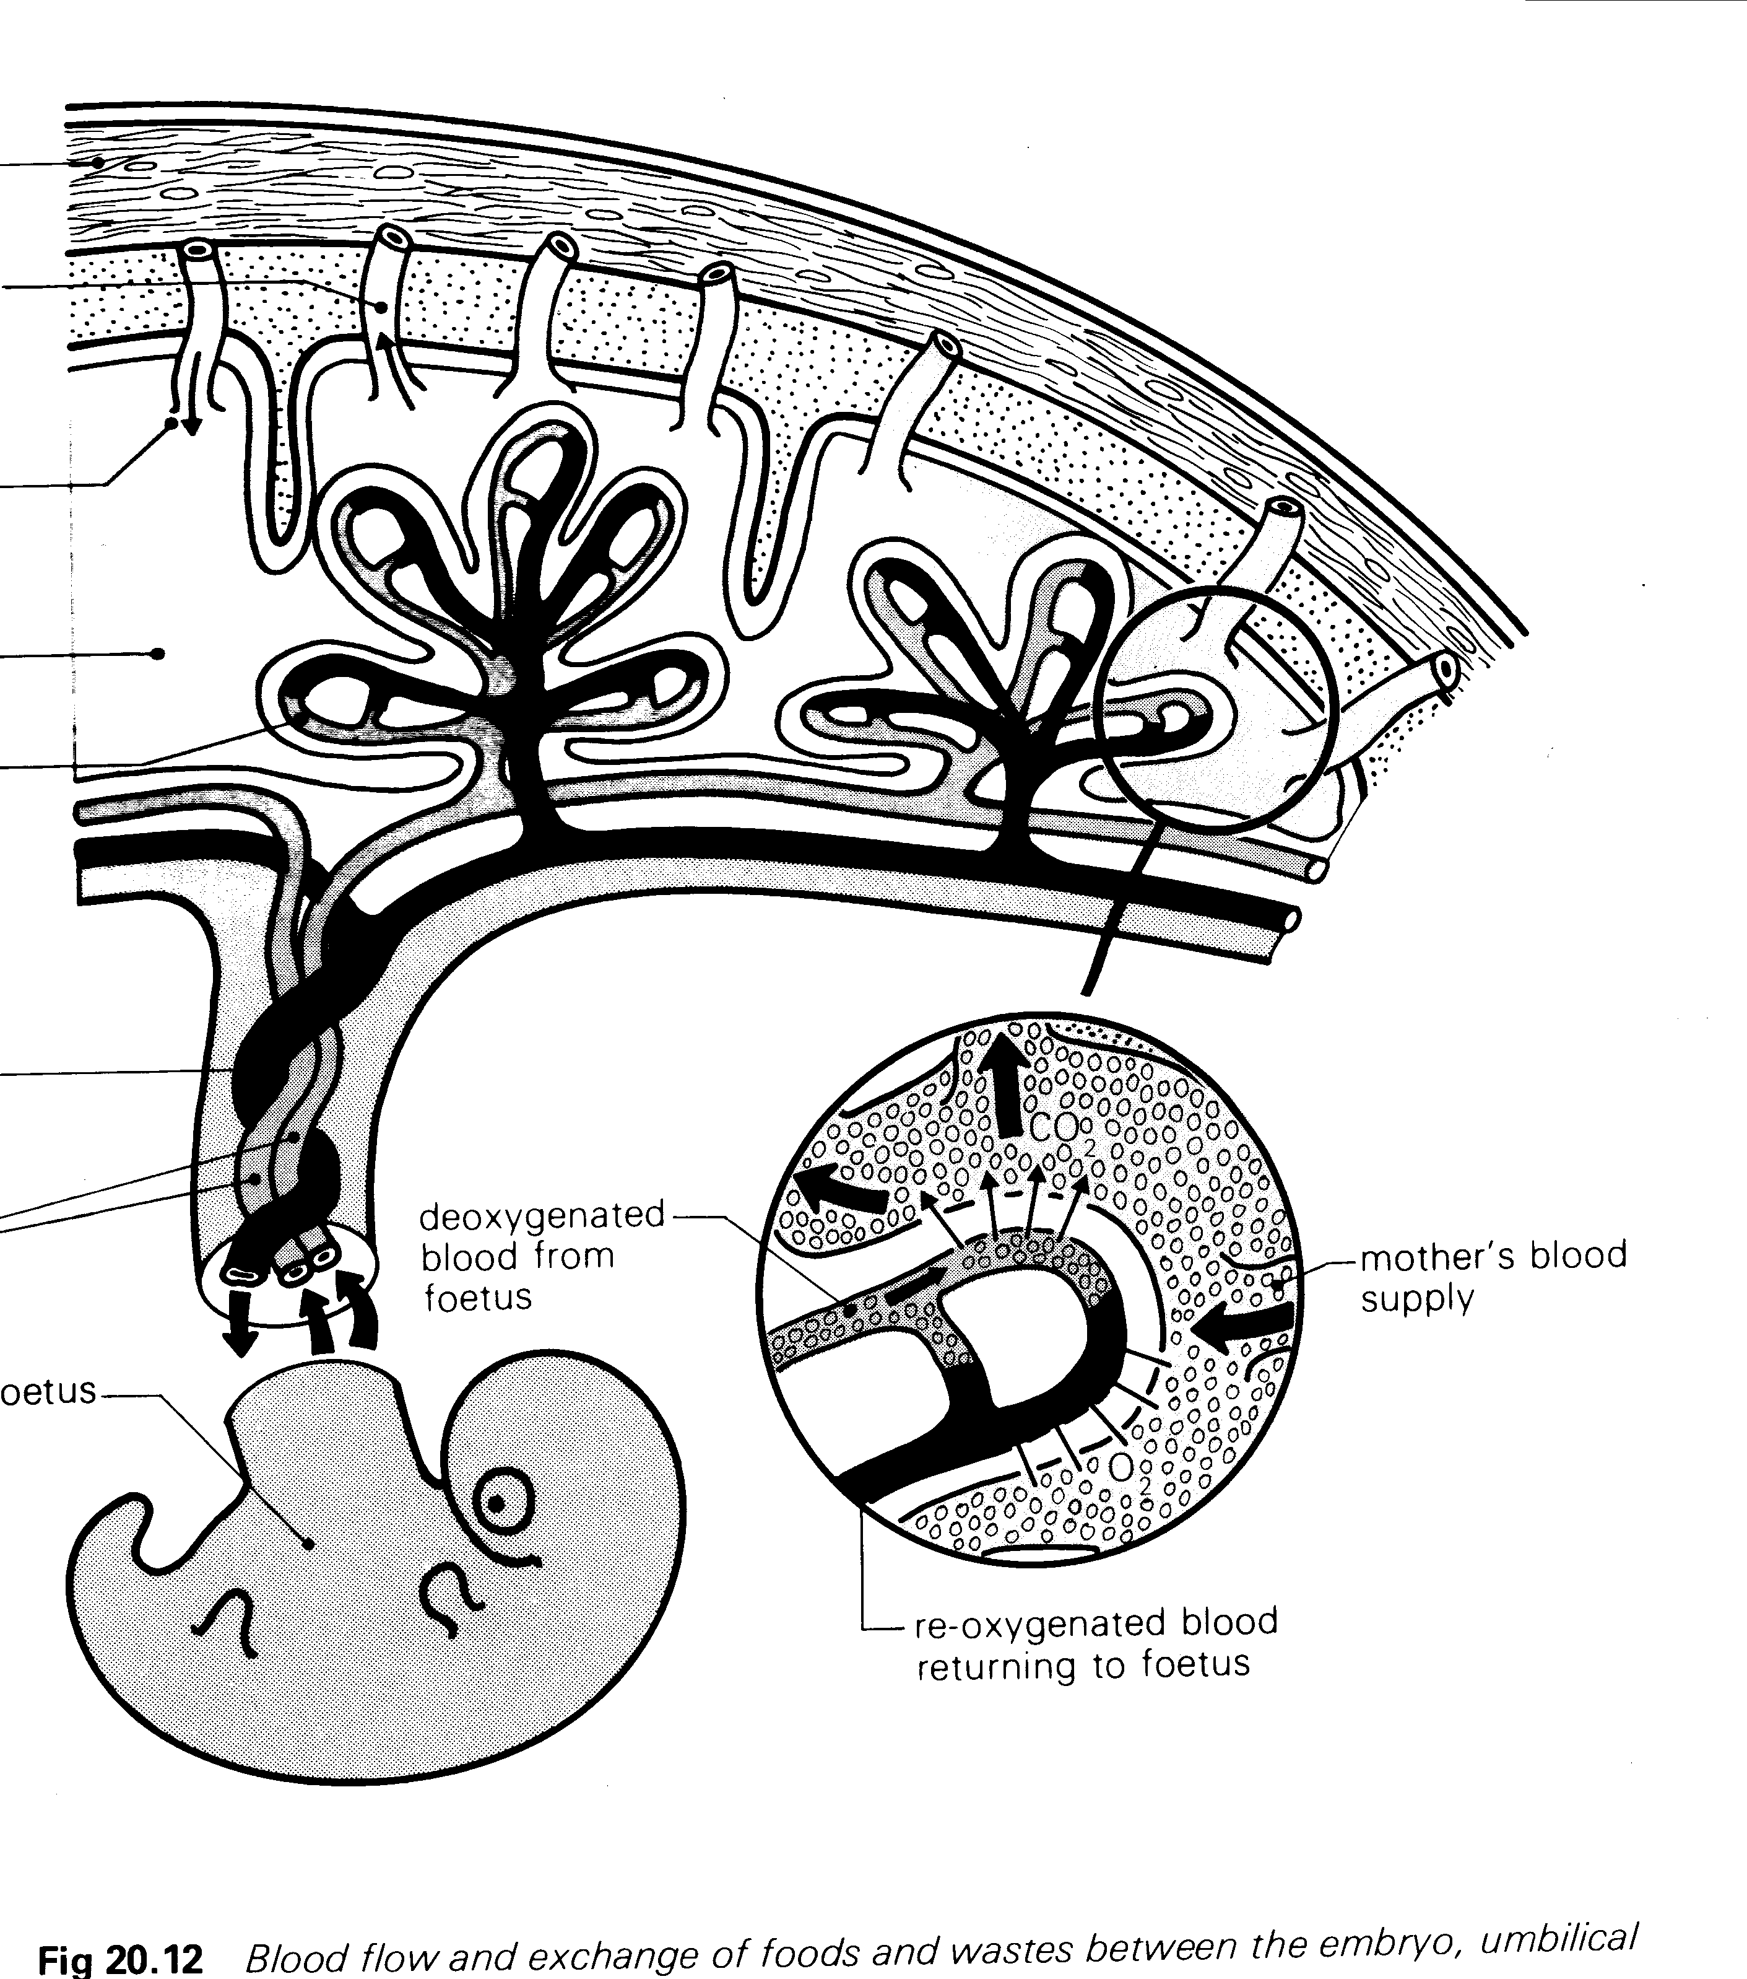

**[7 marks]**

7. Label the following diagram of foetal circulation.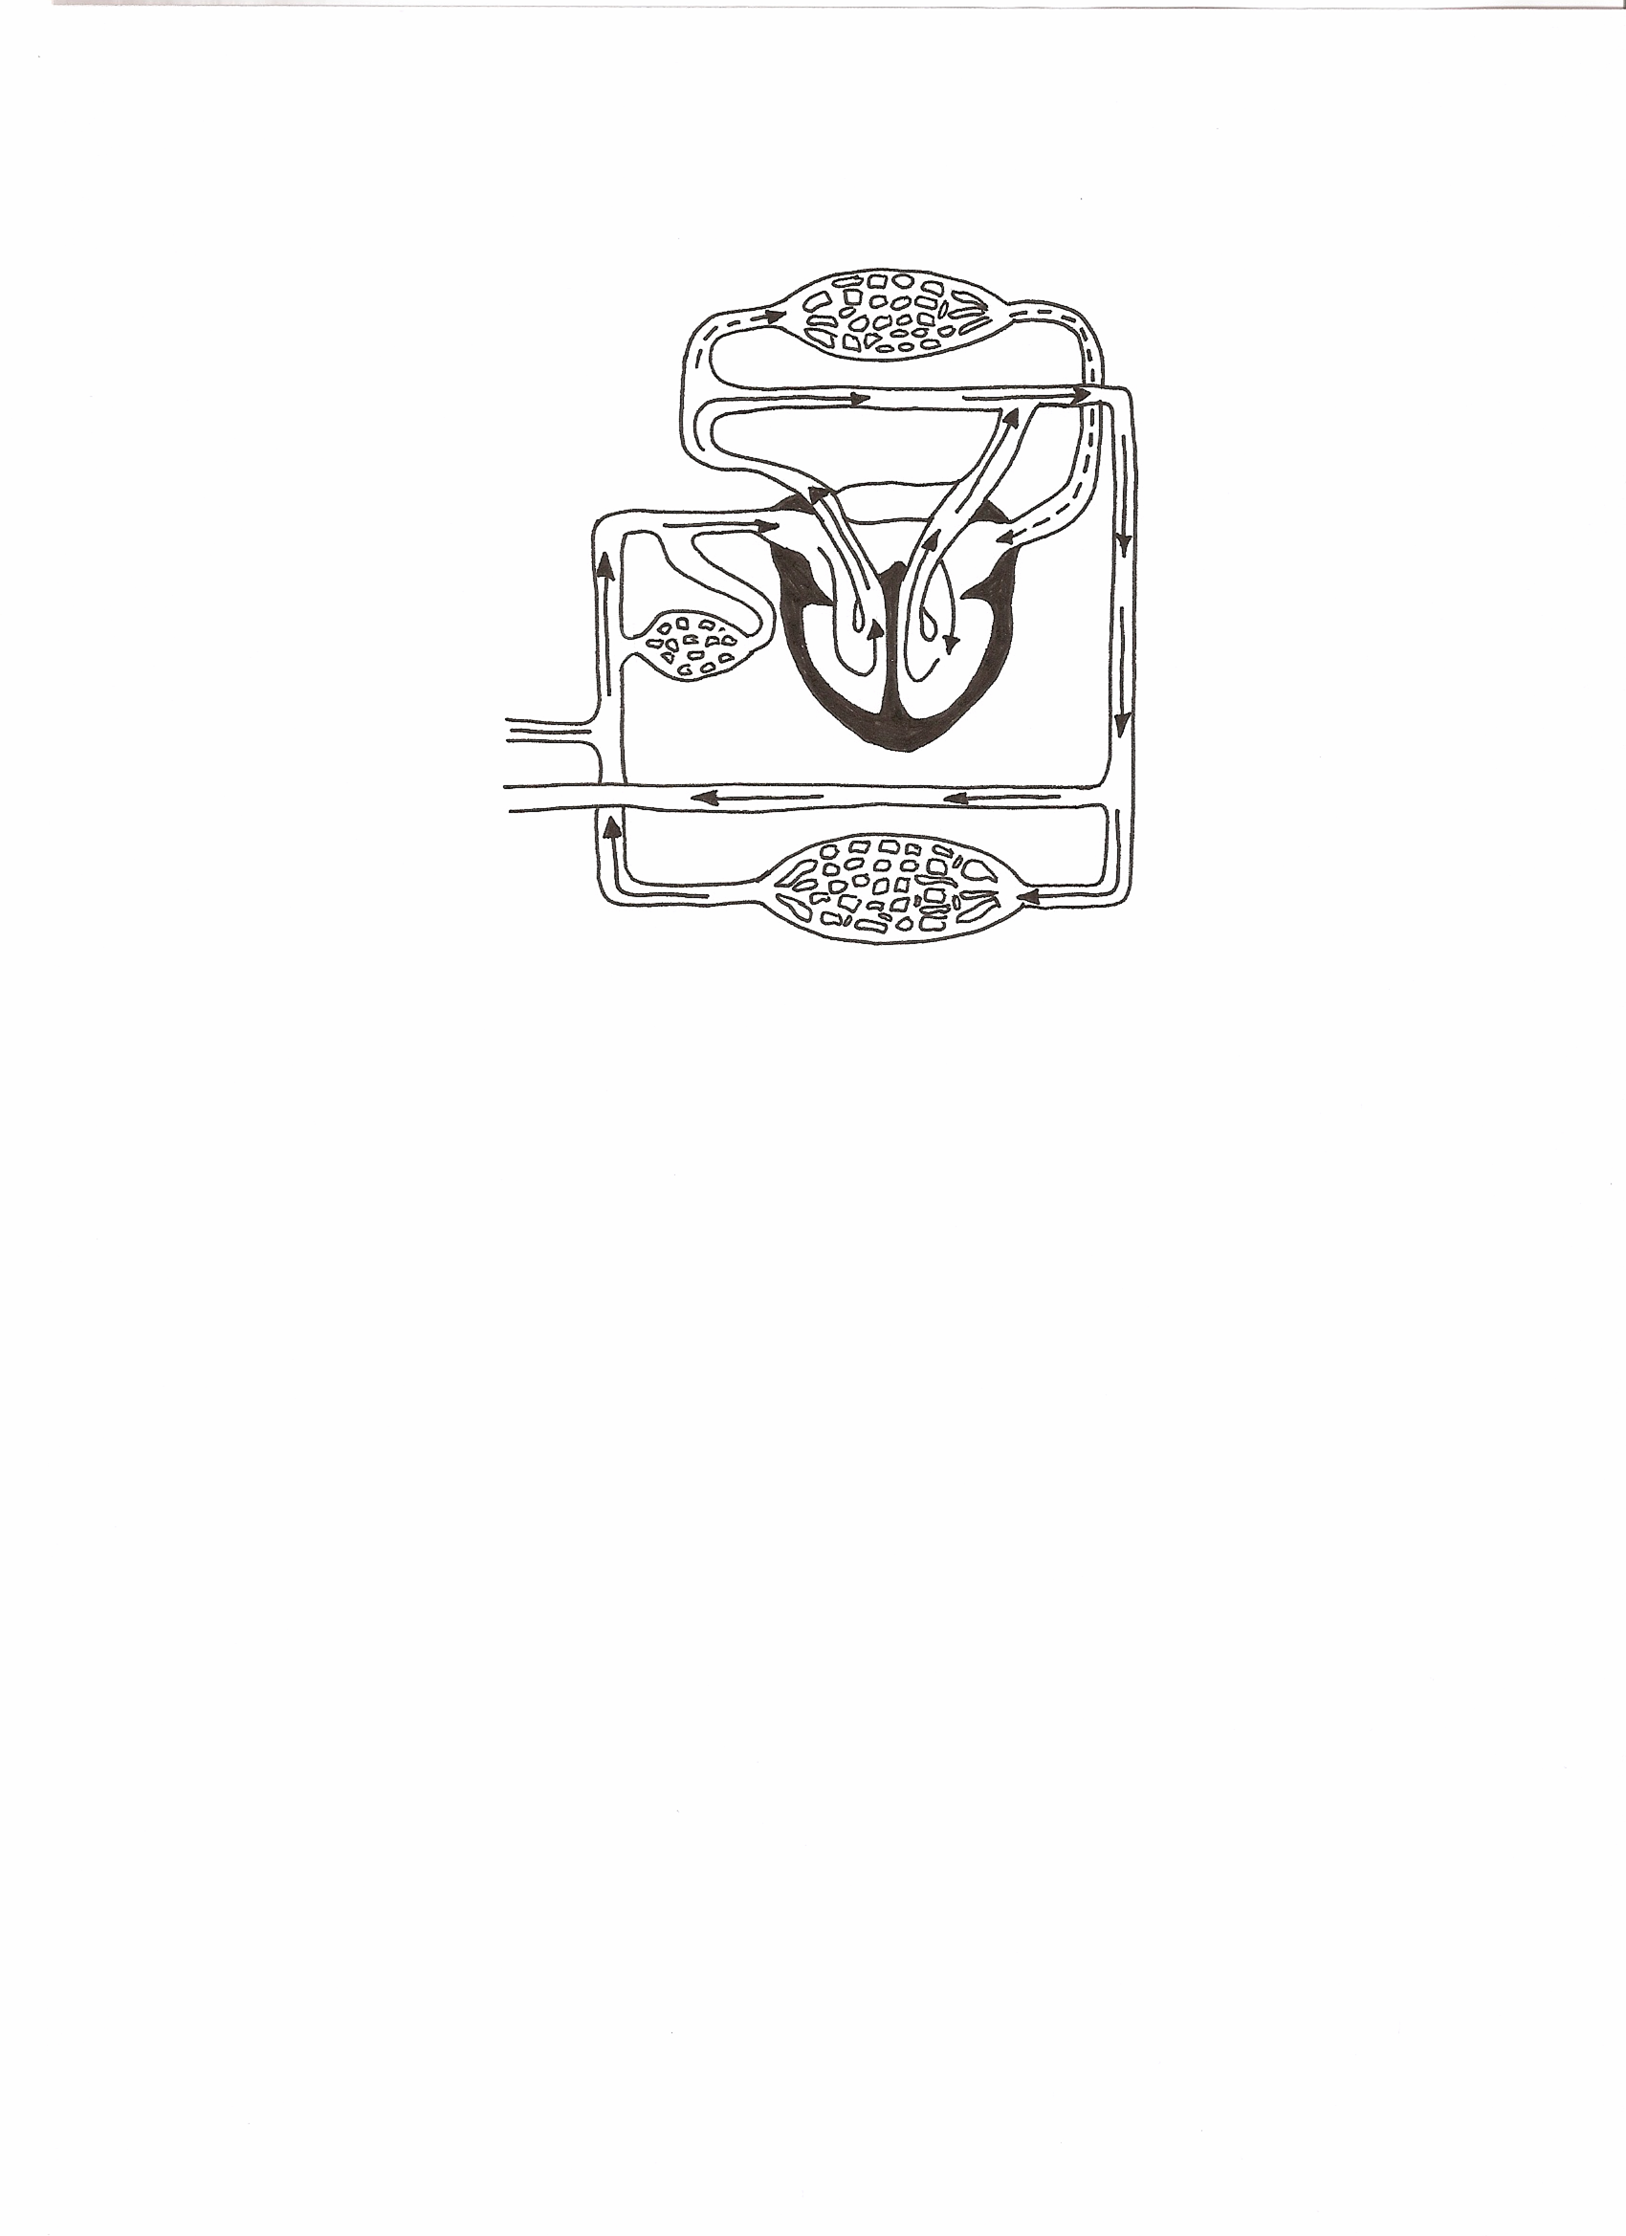

**[7 marks]**

PART C: Extended Answer question [ 28 marks]

Pregnancy is a time of major changes to both mother and child. Once the baby is born, this time of change continues as both mother and baby adjust to the post pregnancy world.

1. In dot point form describe and explain the purpose of **four** physical or functional changes that happen to the baby once it is born. Similarly, in dot point form, describe and explain **3** physical changes which happen to the mother in the approximately 8 weeks following giving birth

.[14 marks] .

___________________________________________________________________________

___________________________________________________________________________

___________________________________________________________________________

___________________________________________________________________________

___________________________________________________________________________

___________________________________________________________________________

___________________________________________________________________________

___________________________________________________________________________

___________________________________________________________________________

___________________________________________________________________________

___________________________________________________________________________

___________________________________________________________________________

___________________________________________________________________________

___________________________________________________________________________

___________________________________________________________________________

___________________________________________________________________________

___________________________________________________________________________

___________________________________________________________________________

___________________________________________________________________________

___________________________________________________________________________

___________________________________________________________________________

___________________________________________________________________________

___________________________________________________________________________

___________________________________________________________________________

___________________________________________________________________________

___________________________________________________________________________

___________________________________________________________________________

2. There is a great range in the sizes and shapes of the female breast but they all function in a similar manner during lactation.

a. What does the term lactation refer to? [2 marks]

b. Label the following numbered parts from the diagram below: [4 marks]

3.___________________________________

4.___________________________________

5.___________________________________

6.___________________________________

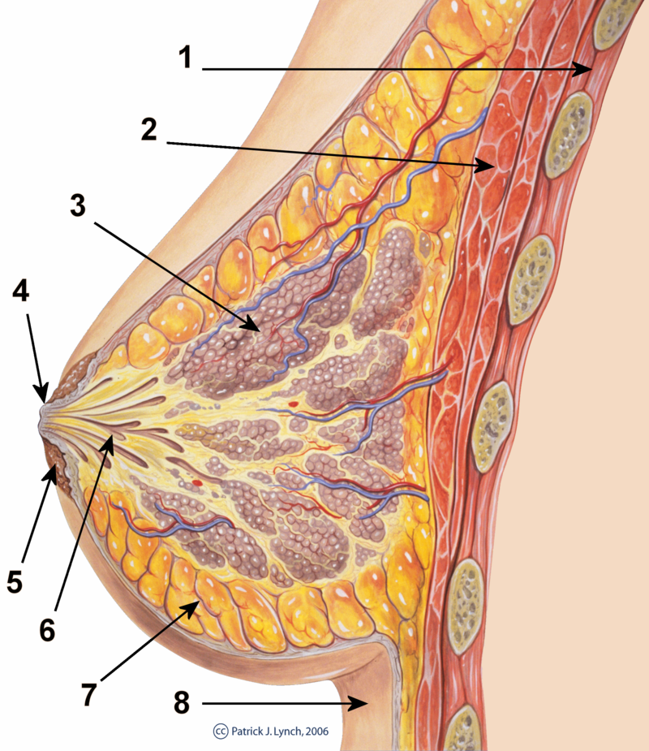

c. Explain how the structures of the human breast numbered 3, 4, and 6 above, are related to the process of lactation. Also include a description of the initial discharge from the breast, and how it differs from later milk produced by the mother.

[8 marks]

___________________________________________________________________________

___________________________________________________________________________

___________________________________________________________________________

___________________________________________________________________________

___________________________________________________________________________

___________________________________________________________________________

___________________________________________________________________________

___________________________________________________________________________

___________________________________________________________________________

___________________________________________________________________________

___________________________________________________________________________

___________________________________________________________________________

___________________________________________________________________________

___________________________________________________________________________

___________________________________________________________________________

___________________________________________________________________________

___________________________________________________________________________

___________________________________________________________________________

___________________________________________________________________________

___________________________________________________________________________

___________________________________________________________________________

___________________________________________________________________________

___________________________________________________________________________

___________________________________________________________________________

___________________________________________________________________________

___________________________________________________________________________

___________________________________________________________________________

___________________________________________________________________________

___________________________________________________________________________

___________________________________________________________________________

___________________________________________________________________________

___________________________________________________________________________

**END OF TEST**